

**COMPUTING COLLEGE**

**DEPARtMENT** COMPUTER SCEINCE

**Title :-** **Web Based Pharmacy Managment System For Debre Berehan Red Cross**

**GROUP -8**

**GROUP MEMBERS FULL NAME ID NO:**

1. BUZEAYEAHU GIRMA 1760/11
2. TSEGAYE MERSHA 1770/11
3. GIRMA ZELALEM 1771/11
4. NEJAT SEID 1290/10

5) BESELAM WESENA 1765/11

**Date of submission: 11**-09-14 E.C

**Submitted to: Ins.**  Chalew

Table Of Content

**CHAPTER ONE: INTRODUCTION 1**

1.1 Introduction 1

**2.Objectives of the project 1**

2.1 General Objective 1

2.2 specificObjective....................................................................................1

**3 Existing System 2**

3.1 Overview 2

3.2. Users/Actors of the system 3

**4. Proposed System 3**

*4.1 Overview* 3

4.2 Functional Requirements 4

4.3. Use Case Model 5

4.4 Class Diagram 6

4.6 Database Design 7

**CHAPTER ONE: INTRODUCTION**

# CHAP1.1 IntroductionONE: INTRODUCTION

## 1.1 Introduction

Pharmacy is a place where drugs are stored and sell for peoples and also other items like cosmetics and medical related items are sold other than drugs. Our project focuses on the drug management system of a pharmacy. This project is concerned on drugs management system of Debre Berhan Red Cross pharmacy. The web based pharmacy management system is a system that manages information about drug. Currently the pharmacy management system in Debre Berhan Red Cross pharmacy is manual which is difficult to manage information, because it causes information inconsistency and data integrity problem. To overcome this information inconsistency and integrity we need to have a web based data management system. We have taken the drug management system, to change the existing system from manually to web based application system. The efficiency of the Policing function and the effectiveness with which it tackles the improper and corrupted managing of drugs depends on what quality of information it can derive from its existing records and how fast it can have access to it .

# 2.Objectives of the projectf the project

## 2.1 Gen2.1 General objectivee

The main objective of our project is to develop web based pharmacy management system and online shopping for Debre Berhan Red Cross .

## 2.2 Spec**2.2 Specific Objective** Objectives

The specific objectives of the project are.-

The System must register new drug and pharmacists Item when the employer wants to add new Item.

To give sufficient drug delivery system for the patient.

To easily report expired medication

To arrange the type of drug based on pharmacological action on the shelf.

To provide quick information on the drug and its description and easy access on search.

The System notifies the item at the expired date.

The system must do like set, update, delete, insert and search drug type of the item.

Designing user friendly interface.

Advertisement of drugs for the user.

Online payment

The objectives are to solve the problem in the existing system, because of the manual work, so we want to reduce the above problem we can develop computerized system.

# 3 Existing 3 Existing Systemem

## 3.1 Overvi3.1 Overview

Debre Berehan Red Cross pharmacy starts its service 1971 E.C, this pharmacy located in Amahara region, Debre Berehan town, which is a pioneer humanitarian organization to help war and disaster victims as well as to assist in reducing the number of vulnerable people through improving access to health facilities, fighting HIV/AIDS, malaria, T.B and other diseases, in developing workable resource generation mechanism so as to become a self-reliant national Society. These pharmacies were unable to give sufficient service to patient because of so many problems. This pharmacy has its own budget; it sells drugs with lowest price (approximately less than 25%) to other pharmacies in the town. Even though this pharmacy gives the above benefit to the society but it has its own problems:

The task was performed manually.

There is no well arrangement of drugs.

It’s difficult to know the expired date of drugs.

It’s difficult to know the Drug that has less quantity.

It is difficult to manage or getting quick information the exact place of the drug on the shelf.

Generally by doing such kind of problem the system was incur so many costs but in the new system we are trying to solve the problems by retrieving the needed information from the drugs management database system this reduced unnecessary cost incurred in the current system.

## 3.2. Users/A3.2. Users/Actors of the systems of the system

* Manager
* Pharmacist
* accountant
* Patient

# 4. Proposed S4. Proposed Systems

## *4.1 Overview4.1 Overview*

After observing the current manual Drug Management system and understanding all the problems occurred during every activity on the existing system of Debre Berehan red cross pharmacy, we desired to design a system that solve the problems of the current system. The proposed system has server, database and client. The server used to fetch data from the database and store data in to the database according to the instruction of the user. Database used to store data and information about drug and patients. The client is display the pages to the user and after the user insert input the client send the request to the server and also display the response of a server to the user. The system that we are proposed store all the details of the drug including their name, type, expired date and all the information related to it. The proposed System will also supports: handling inquiries from prospective pharmacy manager, handling the drug details. It becomes essential to make a properly managed Drug Order management System so that users can easy access drug's record and get the desired information easily. In addition to this proposed system has several advantages including: User friendly interface, Fast access to database, less error, more storage capacity, search facility, look and feel environment, Easy to handle and feasible, cost reduction, fast and convenient and accurate. The proposed system will use the major functionality of the existing system able to advance accordance with performance (the system will have faster response time and use minimal space usage), security (provides or contains user name and password for each users based on their privilege), reliability (system is reliable by analysing each information by the organization of the system) and Speed (regarding on the speed the system will generate output).

## 4.2 Functional Requi4.2 Functional Requirmentsrements

The functional requirement of the Project is defines a function of our System and its components. A function is described as a set of inputs, the behaviour, and outputs. Functional requirements also describe the relations between the system and the user or the environment. Here the ‘relations’ means the direct or indirect interactions between the user and the system.

The functional requirement of our system is:-

* The system shall allow employee login to the system by using their username and password.
* Our proposed system includes reports that are done on the week, Receipt and other related operation.
* The system allows to know easily the quantity of the drug that are existed in the pharmacy it is used to differentiate the expired drug from unexpired because of these we can reduce the wastage of the resource (drug) and money.
* To arrange the type of drug based on pharmacological action on the shelf.
* To provide quick information on the drug and its description and easy access on search.
* The System notifies the item at the expired date.
* Allows authorized user /personnel to update the database.
* The system shall allow employee to logout by pressing log out button.

## 4.3. Use Case Mode4.3. Use Case Model

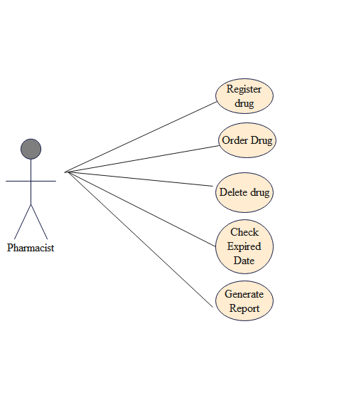

## 4.4 Class Diagram

## 4.4 Class Diagram

## 

# 4.5 User Interface mockup

## 4.5 User Interface Mock up

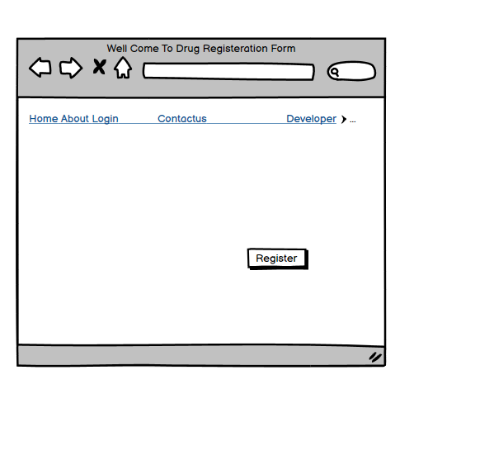

# 4.6 Database4.6 Database Design

## Design

